EXHIBIT D

Community Funding Request

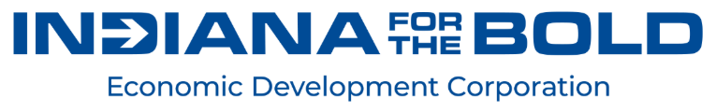
IDD COMMUNITY FUNDING REQUEST FORM

INSTRUCTIONS: This Innovation Development District Community Funding Request (“Community Funding Request”) shall be completed and submitted by the City of Lebanon (the “City”) to the Indiana Economic Development Corporation (the “IEDC”) to request a disbursement from the Lebanon IDD Fund 2 in relation to the IEDC’s IDD Agreement. Please complete this Community Funding Request in its entirety. Sections that are not applicable should be noted as such. Additional documents may be attached to this Community Funding Request as necessary. This Community Funding Request must be submitted to the IEDC at rmichal@iedc.in.gov. The IEDC shall have thirty (30) days to evaluate this Community Funding Request. If additional time is needed to evaluate a submitted Community Funding Request, the IEDC shall notify the City of a date by which its decision can be expected. During the evaluation period, the IEDC may request additional information. The IEDC reserves the right to deny disbursement or condition its approval of IDD Funds on conditions as it deems appropriate. Written notice of approval, conditional approval, or denial shall be sent to the City contact indicated below.

SUBMISSION STATUS
Please check one.
____ New Community Funding Request ____ Amended Community Funding Request

PROJECT ADMINISTRATOR INFORMATION

Community Name:_______________________________________________________________

Name: _______________________________________________________________________

Title: ________________________________________________________________________

Relationship to Community (i.e. attorney, financial advisor):
______________________________________________________________________________

Address: _____________________________________________________________________

City: _______________________________ State: ____ Zip Code: ___________________

Primary Telephone Number (including area code): _________________________________

Additional Contact Telephone Numbers: __________________________________________

Email Address: ________________________________________________________________

PROJECT INFORMATION

Project Name(s): ______________________________________________________________
______________________________________________________________________________

Project Address(es): ___________________________________________________________
______________________________________________________________________________

Brief Description of Project: ____________________________________________________
______________________________________________________________________________
__________________________________________________________________________________________________________________________________________________________________________________________________________________________________________

Specify Project’s Connection to IDD Plan: _________________________
______________________________________________________________________________
__________________________________________________________________________________________________________________________________________________________________________________________________________________________________________

Specify any Deviations from Project, as approved in IDD Plan:
______________________________________________________________________________
__________________________________________________________________________________________________________________________________________________________________________________________________________________________________________

Expected Project Timeline (commencement to completion): __________________________
______________________________________________________________________________

FINANCIAL INFORMATION

Total Project Budget:

Itemized Breakdown of Project Budget:

Firm Public and Non-Public* Financial Commitments, Including:
- Type (e.g. Loan, Grant, Tax Credit, Equity)
- Amount
- Distribution Schedule
- Status

Pending Public and Non-Public* Financial Commitments, Including:
- Type (e.g. Loan, Grant, Tax Credit, Equity)
- Amount
- Distribution Schedule
- Status

*Examples of Financial Sources Include:
- Non-Public Support (i.e. in kind contributions, private debt, private equity, philanthropic or private foundation dollars)
- State Public Support (i.e. State IDD Funds, state incentives, state grants, university funds)
- Other Public Support (i.e. local revenue source permitted by law, distributions, incentive payments, local major moves money, money received by local communities through a local casino development agreement, municipal bonds, federal grants)

Total Disbursement Amount Requested from Lebanon IDD Fund 2:

COMMUNICATIONS

Primary Public Relations Contact for Project: _____________________________________

Contact Telephone Number (including area code): __________________________________

Contact Email: ________________________________________________________________

Do you anticipate any of the following public relations functions in conjunction with this project? (check any that apply)

Press Release
If yes, please include expected timing: _______________________________________

Event (e.g. Announcement, Groundbreaking and/or Ribbon Cutting)
If yes, please include type of event and expected timing: _______________________
________________________________________________________________________

SUPPLEMENTAL DOCUMENTATION
Please check the corresponding boxes and attach copies of the following documents to this Community Funding Request, wherein applicable.

Letters of intent from financial institutions
Local financial commitment letters
Contracts with private and public entities
Memorandums of Understanding with private and public entities
Ordinances/resolutions
Cost estimates from qualified sources
Environmental and permitting documents
Architecture/engineering drawings
Development agreements
Developer qualifications
Proof of ownership documents
Tenant/end user commitments
Other relevant Project documentation: _____________________________________
________________________________________________________________________

REPRESENTATION AND AFFIRMATION.

The undersigned represents and affirms that the undersigned is the properly authorized representative, agent, member or officer of the City and is therefore the duly authorized signatory to execute this Community Funding Request on behalf of the City and has obtained all necessary or applicable prior approvals from the City. Additionally, the undersigned affirms that the information and supplemental documentation contained in this Claim Form is true and current under penalty of perjury.

_________________________________________
Signature

_________________________________________
Printed Name, Title or Position

_________________________________________
Date

EXHIBIT E

Claim Voucher
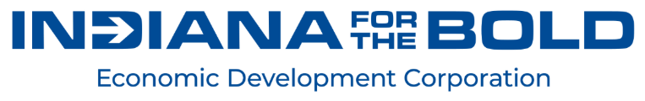

CLAIM VOUCHER

Date:
Entity Invoice #:
IEDC Grant ID:
Project #:
YOUR COMPANY NAME

Street Address
City, State Zip
Phone____________ Fax__________
IEDC USE ONLY
Purchase Order #:
Invoice #:
Voucher #:

Remit Via Email to:
Indiana Economic development Corporation
One North Capitol Avenue, Suite 700
Indianapolis, Indiana 46204
Processing@iedc.in.gov

DESCRIPTION | AMOUNT
Total Purchases  Total Contractual Expenses | $ -  $ -  $ -  $ -
Progress Report | $ -  $ -  $ -  $ -

